The Case of

John McCarthy

Examining Blood Pressure

Paul Redmond
Teachers notes
The case of John McCarthy
____________________________
Syllabus links:

The Circulatory System

Equipment required:

Data Logger (Pulse Rate)

What you need to do in advance:

Prepare a List of questions to ask the students. Questions must require only yes and no answers. Questions must be straight forward and easily answered without embarrassment.

Expected results:

The Experiment is designed to find out if a person when lying will have an increase in their pulse rate.
Student worksheet
The Case of John McCarthy

The crime

John McCarthy has been arrested for murdering his wife. The police are unsure if they have arrested the right man. Unfortunately the Polygraph machine is not working correctly and it will take a week to order the new part. The police ask you whether there is any other way of determining whether a person can be tested to see if they are lying or telling the truth. They need something to tell the court if they are to retain him in custody.
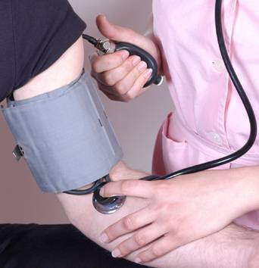
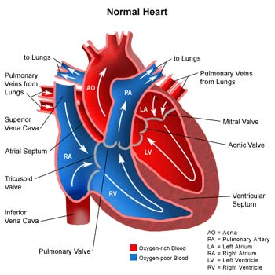
Your mission:
To find out if there is a link between a person’s blood pressure and whether they are telling the truth.

What you need to do to solve the crime!

Attach each student to the data logger. Note the students pulse rate at rest (________beats per minute)

Did the students pulse | Go Down | Stay the same | Rise
1.
2
3.
4.
5.
6.
7.
8.
9.
10.

From the results of this experiment can you say that there is a link between a person’s pulse rate and whether they are telling the truth or not?

